Name: _________________________________________ May 2, 2014 Period: _________

Early Years of the Cold War: 1945-1955

Cold War Roots- Review
- Following WWII the US and USSR were the only two ___________________________________________ left
- Soon after WWII these two powers were in a Cold War (Icy Tensions)
- Why?
  - Different economic systems, strategic interests, Stalin’s Speech, Iron Curtain Speech, Atomic Weapons, etc.
Pre-Cold War Distrust
- US
  - ___________________________________ was antithesis of Democracy/Freedom/Capitalism
  - Stalin’s Purges
  - Non-Aggression Pact
  - USSR emphasis on worldwide communism
- USSR
  - US attempted to undo Revolution
  - _______________________________ attack on Western Front during WWII
  - Believes peace will come from ___________________________________ communism
Early Problems - Review
- Yalta Conference
- Potsdam Conference
- Containment - ________________________________________________________________________________________
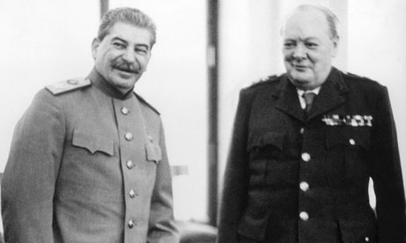
  - Truman Doctrine
  - Marshall Plan
- Alliances
  - North Atlantic Treaty Organization (NATO)
  - Warsaw Pact
Speeches set tones
- Winston Churchill (Great Britain)
  - Claimed an “_________________________________________” had descended on Europe because of communism
- Joseph Stalin (Soviet Union)
  - Gives speech saying capitalism and communism cannot exist in same world
  - Stalin calls Churchill’s speech an “_______________________________________”
Berlin Blockade & Airlift
- May 1948 - June 1949
- Stalin cuts off access to Berlin, US sends airplanes with _________________________________ for over a year
- Stalin backs off, Victory for West
USSR/China- 1949
- USSR develops _______________________________________________________
- Arms race develops between US and USSR
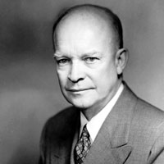
- China falls to the Communists
Brinkmanship
- President Eisenhower and his Secretary of State, John Foster Dulles, issue the policy of ______________________________
  - Threatening massive retaliation in order to get the other side to back down
Korean War
- Communist North Korea invades __________________________________ South Korea
- UN and West help South Korea while Soviet Union and China aid North Korea
- Fighting lasts from 1950-1953
- Ceasefire signed in _________________
  - The two nations are technically still at war!
- North and South divided by _____________________________________________
Domino Theory
- Theorized that if one country in a region fell to communism, all the others might follow
- Used to justify the U.S. policy of _________________________________________
