Name: ___________________________________ Date: ____________________ Period: _____
End of the Cold War: 1975-1991
Richard Nixon and Détente
- Détente
  - _____________________________________________________________________________________________
- Real Politik
  - dealing with nations in a practical and flexible manner (anti-containment)
- Nixon visits China
- SALT Treaties
  - _____________________________________________________________________________________________
  - Limited nuclear weapon production
- Policies continued with Gerald Ford and Jimmy Carter

- How was the policy of Real Politik different from the policy of containment?

Ronald Reagan
- Fiercely ________________________________________________
- Moved Away from Détente
- Increased Military Spending to try to bankrupt the Soviet Union
- Demanded the demolition of the ______________________________________________

- Were Ronald Reagan’s policies closer to Real Politik or containment? Explain.

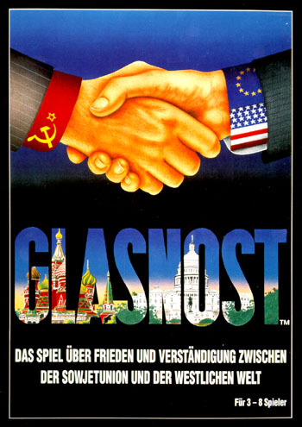
Change in the U.S.S.R.
- Mikhail Gorbachev becomes Premier of the Soviet Union in _________________
- Begins a series of Reforms and Freedoms in Russia
  - Glasnost
  - Perestroika
  - Democratization
Glasnost
- Glasnost = ______________________________________
- Churches opened
- Press allowed to criticize government
- Banned authors allowed to publish books

Perestroika
- Perestroika = __________________________________________________
- Managers make more decisions
- Small private businesses
- Democratization

Democratization
- Democratization = ____________________________________________________________________________________
- Election of a new group of lawmakers
- Communist Party no longer chose all candidates

- How did the policies of Glanost, Perestroika, and Democratization change the Soviet Union?

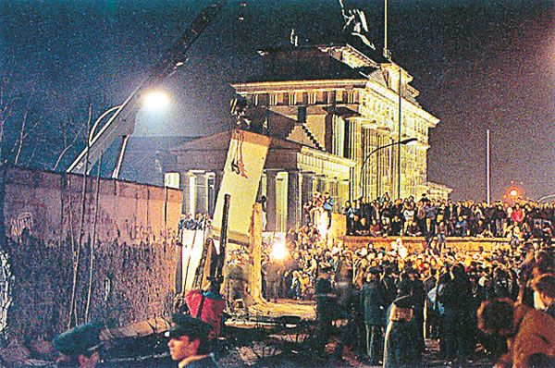
The Berlin Wall
- Berlin Wall falls in ______________________
- Symbolic of end of Cold War
- Process of reunification of East & West _______________________________

USSR - 1991
- Nationalities begin to call of Independence
- August Coup, by Communist Hardliners
- Boris Yeltsin seen as hero, becomes ____________________________ of Russia

Russia since the Cold War
- Boris Yeltsin, President 1991-1999
  - Formed Commonwealth of Independent States (CIS)
- ________________________________________________ becomes President in 1999
  - Tightened Grip of government on Economy
  - Restricted Voting Rights and Liberties
  - Still the leader of Russia!

- Why was the fall of the Berlin Wall “symbolic” of the end of the Cold War? Explain.

