Name: _______________________________________________ April 30, 2014 Period: _________

The End of World War II

Directions: Use the video and the notes to complete the information in your notes today. When you are finished, use the notes to complete your exit ticket.

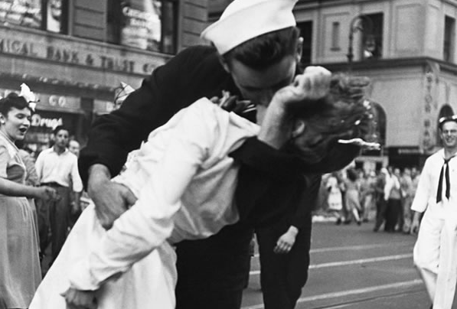
War Ends in Europe
- List three events that helped bring World War II to a close in Europe:
- ________________________________________________
- ________________________________________________
- ________________________________________________
The Germans Surrender
- The ______________________ reached Berlin first
- Adolf Hitler found dead in a bunker—a __________________________
- Berlin surrendered on May 2, 1945: Germany five days later
- Victory in Europe (________________________) proclaimed May 8, 1945 after 6 years of fighting
War Ends in the Pacific
- Final Battles
  - By mid-1944, regular bombing raids on Japanese cities, including Tokyo
  - Great distance made raids difficult, dangerous
  - Americans needed bases closer to Japan
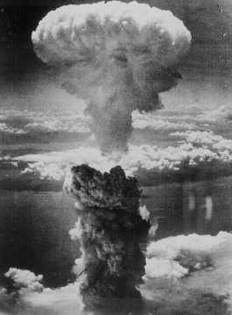
- List three battles that helped end the war in the Pacific:
  - ________________________________________________
  - ________________________________________________
  - ________________________________________________
- The Atomic Bomb
  - After Okinawa, mainland ___________________ was next
  - What two cities were targeted by the atomic bombs?
______________________________ & ______________________________
  - Emperor Hirohito surrendered on August 15, 1945. This day is known as ___________________________ for Victory in Japan.
  - ______________________________________ was finally over.
The Post War World
The Allies planned for the end of the war for years!
Complete the chart below to describe the plans the Allies had for how the world would look after the Second World War:
Conference/Meeting Name | Year | Results
Atlantic Charter
Tehran Conference
Yalta Conference
United Nations Charter
Potsdam Conference

List some of the major effects of World War II:
- ____________________________________________________________________________________
- ____________________________________________________________________________________
- ____________________________________________________________________________________
- ____________________________________________________________________________________
- ____________________________________________________________________________________

