Name: _________________________________________________ April 21, 2014 Period: _________

Failures of the League of Nations – Fill-in Notes

Learning Goals
- Essential Question:
  - At what point is war unavoidable?
- Learning Targets
  - I can recall the purpose of the League of Nations.
  - I can identify the aggressive actions of Hitler that led to World War II.
  - I can define the term appeasement.
  - I can describe why the League of Nations failed in preventing World War II.
- POU (I’ll know I’ve got it when…)
  - I can analyze Adolph Hitler’s actions by giving a detailed explanation of how Hitler’s aggression led to a declaration of war.

League of Nations
- DEFINITION: _________________________________________________________________________________________
____________________________________________________________________________________________________
____________________________________________________________________________________________________
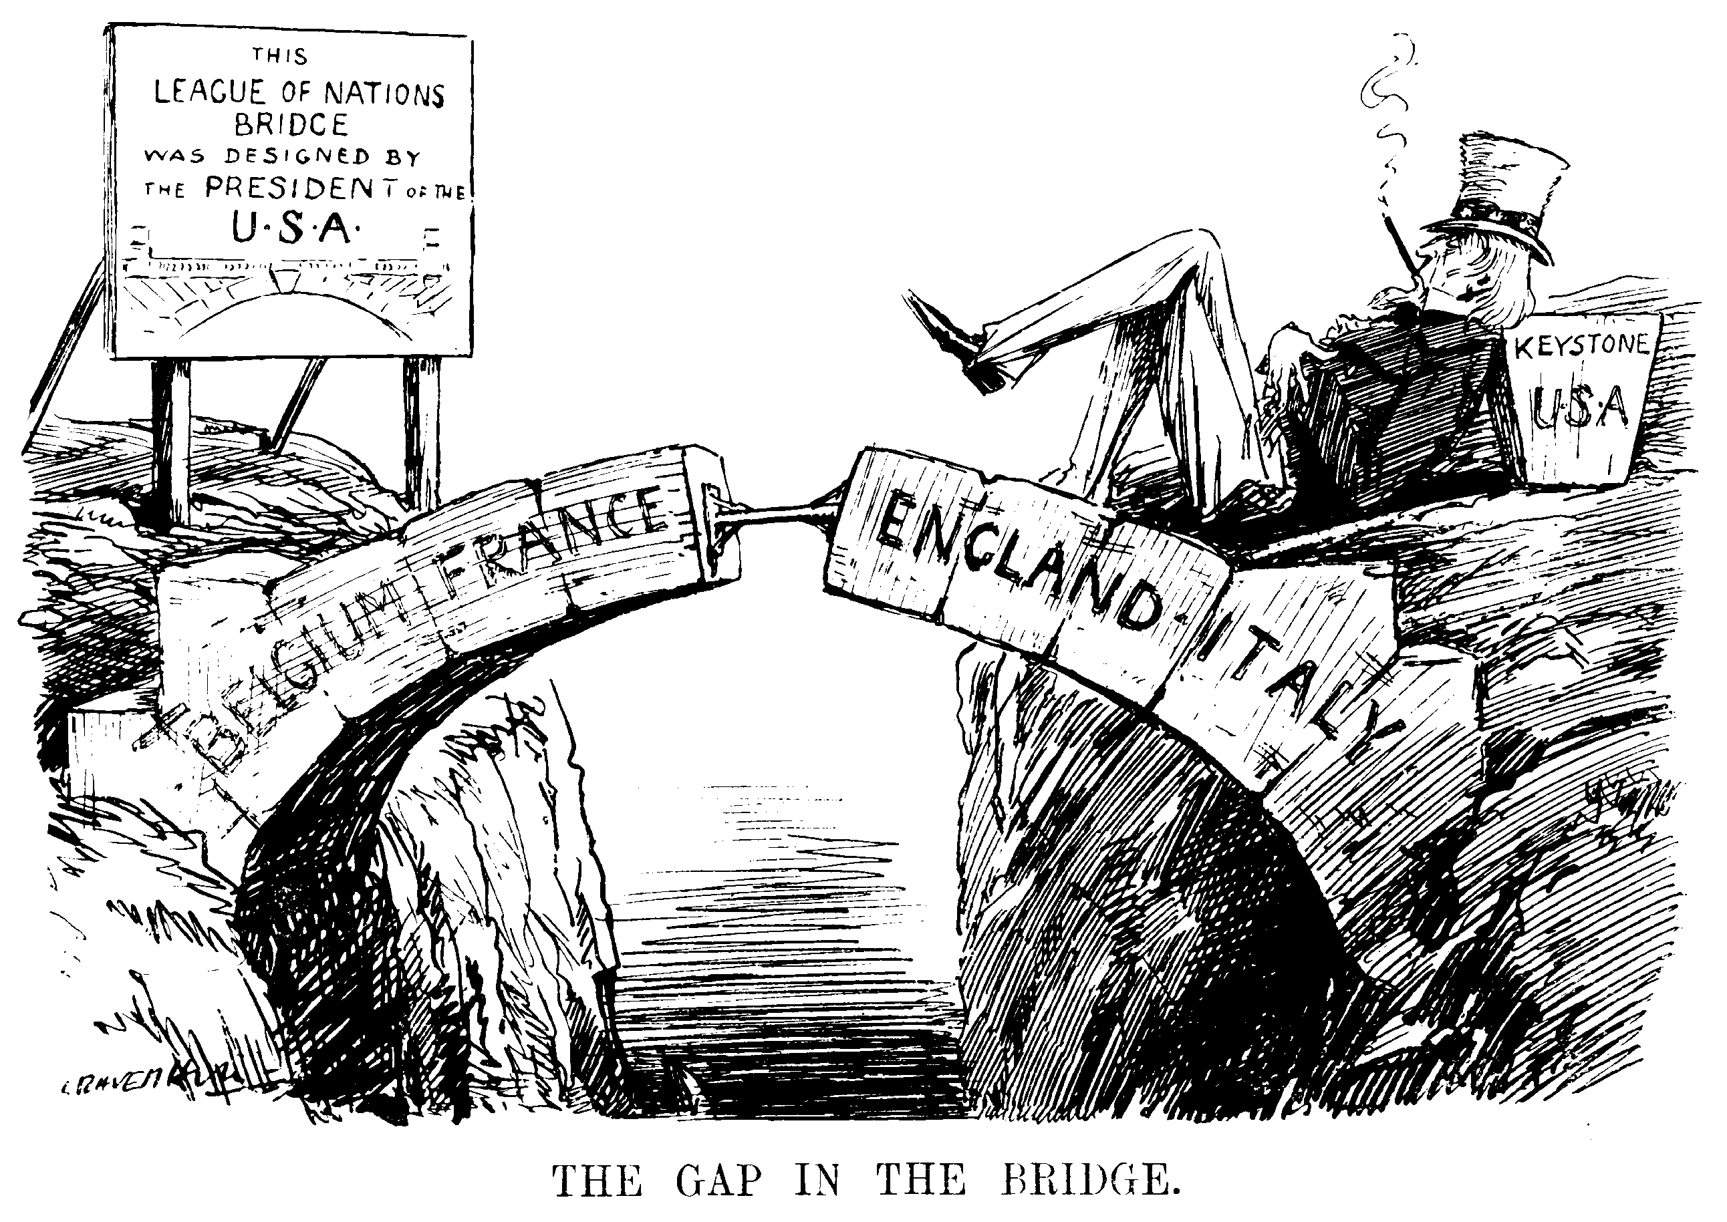
- Proposed by Woodrow Wilson’s Fourteen Points
  - The __________________________ did not join the League!
  - Americans did not want to be caught in an alliance system
- When the League was needed most, it was almost __________________________ to do anything.
The League’s Decline
- Let’s start looking at the events that would simultaneously lead to the breakup of the League of Nations and the beginning of World War II…
- Japan
  - In 1931, Japan is hit badly by economic __________________________.
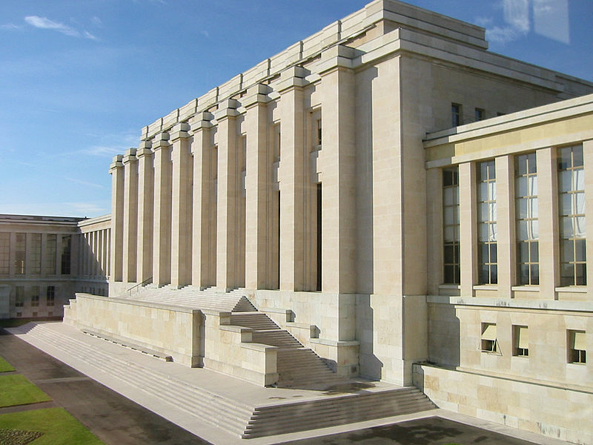
  - People lose faith in the government and look to the army for help.
  - The Japanese army soon invades __________________________ (in China).
- League of Nations’ Reaction
  - It tells Japan not to do it.
  - After Japan does it, they tell countries not to trade with Japan.
    - Many world countries are poor and need Japan to trade with.
    - Countries continue to trade with Japan.
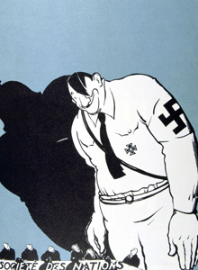
  - The L.O.N. condemned Japan for its actions.
  - In response, Japan decided to ____________________________________________
Hitler’s Rise to Power
- In January 1933, Hitler becomes __________________________ of Germany and exits the League of Nations.
- By 1935, he builds up an army.
- In 1936, Hitler orders army to invade the Rhineland
Hitler’s Aggression
- In 1936, he makes alliances with Japan and Italy.
- In 1938 Hitler takes back Austria, which it had lost in the Treaty of Versailles.
Britain and France
- Britain and France are opposed to Hitler’s moves because they violate the _______________________________________.
- France and Britain are scared of another war
- They begin practicing appeasement
  - DEFINITION: __________________________________________________________________________________
__________________________________________________________________________________________________________________________________________________________________________________________
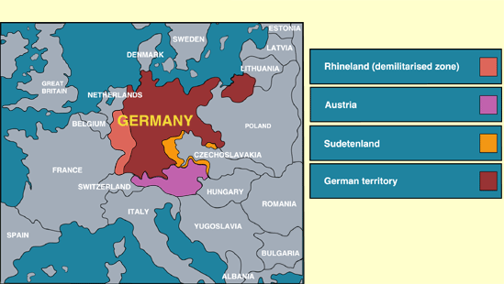
Hitler’s Continued Aggression
- In 1938, Hitler also is given the Sudetenland
- In 1939, Hitler invades Czechoslovakia
- In early 1939, Hitler makes an alliance with the Soviet Union.
- He is preparing to invade Poland...
  - On _____________________________________, the German army invades Poland and quickly takes control
Britain and France
- On September 3, 1939, ________________________ and ________________________ finally declare war on Germany
- They do not want to fight another World War, but they can no longer stand by and let __________________________ take over Europe.
- Plus, they had promised Poland they would help if Poland were invaded.
Why couldn’t the League of Nations stop Hitler?
- It had no army to __________________________ anything
  - Japan, Germany, and Italy expanded without a way to stop them
- Europe did not want another war
  - Countries like Britain and France were still hurting from WWI
- Many countries did not belong to it
  - Without powerful countries, the legitimacy of the organization was questioned
  - Even the __________________________ was not involved!
- It only met ______________ times a year
  - What if your school’s administration or teachers only met 4 times a year? Would enough get done?

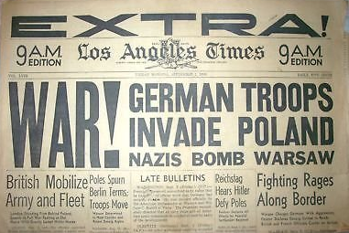
Preview of Tomorrow’s Lesson
- We will examine primary source headlines telling the story of Hitler’s aggression prior to World War II.
- We will look at these together and independently.
- Prepare for discussion, critical thinking, and composing your own article.

