Name: _______________________________________________ April 25, 2014 Period: ________

The Home Front during the Second World War

Wartime Production
- The ________________________________________________ (WPB) organized the effort to make supplies 24 hours a day
- Factories made planes, tanks, weapons, parachutes, etc.
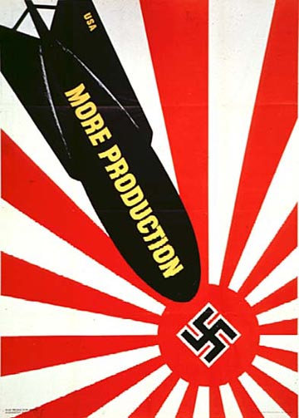
- Due to the need for raw materials, some things became scarce for other Americans
  - No new _____________________ were produced between 1942 and 1945
  - Gasoline, tires, shoes, meat, and sugar were _______________________ (limited to a fixed amount for each family)

Wartime Production by the Numbers
- By 1945:
  - ___________________________ aircraft
  - 75,000 ships
  - 60% of all Allied ammunition
- Unemployment rates fell drastically
- GDP rose from $90.5 billion to _________________________________

Opportunities for Women
- __________________________ entered the workforce by the millions
- Made munitions, ships, planes, etc.
- The U.S. promoted __________________________________________, an image of a strong woman working

Opportunities for Minorities
- Over 1 million African Americans left the south to work in war industries
  - Also led to racial tension in ___________________________________
- 120,000 Mexican immigrants came to the U.S. to work temporarily as part of the __________________________ program
- 46,000 Native Americans left reservations to work in war industries

Japanese-American Internment
- Executive Order 9066 ordered over110,000 Japanese Americans to be moved to ____________________________ camps
  - One-room housing, very little privacy
  - Kept under guard
- Why?
  - The U.S. government was afraid that Japanese Americans were a ________________________ to America

Korematsu v. the United States (1944)
- Fred Korematsu was a Japanese-American who was forced to leave his home and move to an internment camp
- He sued the U.S. government, saying it __________________________________ his rights
- The Supreme Court said that need to protect Americans was greater than Korematsu’s rights

