Name: ___________________________________________ February 21, 2014 Period: _________

Immigration During the Gilded Age

Immigration
- Between 1865-1915, more than ____________________________________ immigrants came to the United States
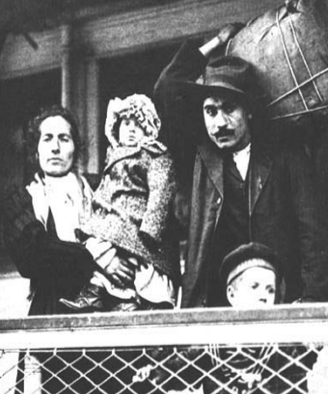
Why did they come?
- PUSH FACTORS
  - ____________________________________
  - ____________________________________
  - Crop failures (Irish)
  - Religious and political problems in their own countries
- PULL FACTORS
  - ____________________________________
  - Economic opportunity
  - ____________________________________
  - “Rags to riches” possibilities
  - Abundant land
How did they get here?
- Passage to the U.S. often cost a life’s ___________________________
- Entire families would save enough to send one or two people to America
- Travel was by ship, often extremely ____________________________________ and full of diverse people
Travel Dangers
- Read the following quote from a U.S. Immigration agent:
  - “During the 12 days in the steerage I lived in…surroundings that offended every sense. Only a fresh breeze from the sea overcame the sickening odors. Everything was dirty, sticky, and disagreeable to the touch.”
- ____________________________________ and even death were not uncommon.
When people arrived…
- Ellis Island – ____________________________________
  - Served as an immigration station on the east coast
  - In its first 20 years, 6 Million immigrants had come through Ellis Island
- Angel Island – ____________________________________
  - Immigration station on the west coast
  - Mostly Chinese and Japanese immigrants passed through
  - Served about ____________________________________ immigrants
Inspection
- Medical exam
- 32 background questions
- Immigrants with contagious diseases were sent back home
- Many immigrants had their ____________________________________ changed at the inspection stations
What was life like?
- Many ____________________________________ (people who were anti-immigration) disliked immigrants
- Immigrants often had to accept low-paying jobs with poor ____________________________________
- Most immigrants lived in areas with people from a similar ethnic background, separated from the rest of the city
  - Chinatown
  - Little Italy
Living Conditions
- Many immigrants lived in crowded tenements
- ____________________________________ were crowded apartments usually with poor conditions
- Uncomfortable, crowded, and dirty
  - 1,231 people in 120 rooms in one part of NYC
  - In Chicago, 40% of infants never reached their first birthday
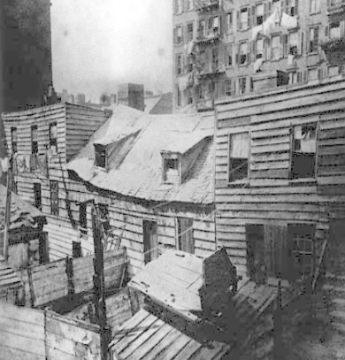
- Some people paid for “_______________________________________________” rooms (a nickel for a one-night stay next to strangers)

