Name: ______________________________________ Date: __________________________ Period: ______

Martin Luther King, Jr. & Malcolm X

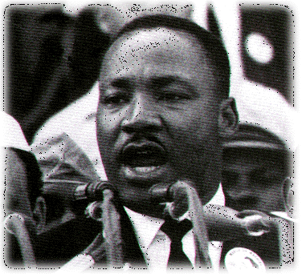
Martin Luther King’s Early Life
- Son of a Baptist Minister from _____________________
- Attended Morehouse College and graduated from Boston University with a Ph.D.
- Became a pastor in _____________________________, Alabama at the age of 24.

Martin Luther King’s Ideology
- Expose the racism, prejudice, discrimination, & brutality that existed in the South
- Use _____________________________________ means to promote the change he wanted.

King’s Movement
- Created the Southern Christian Leadership Conference
- Organized ____________________________________ to conduct non-violent protests
- Used media coverage to expose Jim Crow laws
- King would later win the _____________________________________________.
- Succeeded in passing Civil Rights legislation

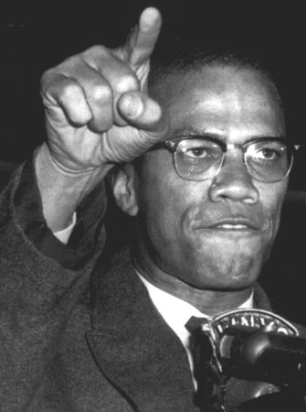
Malcolm X’s Early Life
- Father was ________________ because he was a civil rights activist
- Went to prison for ______________________ for gambling, racketeering, & robbery
- Converts to ____________________ in prison, after his release he becomes a minister for the Nation of Islam
- Changes his last name to X because “Little” was a “_________________________________”
Malcolm X’s Ideology
- Believed African-Americans should stand up and fight for their freedom
- Believed violence was ___________________________ to earn freedom
- Believed that the Christian religion was based on the _____________________ culture
Malcolm X’s Movement
- Member of the _________________________________
  - Taught that Africans belonged at the top of the social order
  - Whites only took advantage of the black race
  - Wanted political and economic black ________________
- He would later leave the Nation of Islam and change his view on Whites and Blacks

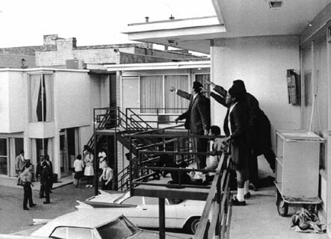
Assassination of MLK
- He was shot outside a hotel in _____________________, Tennessee in 1968 by James Earl Ray
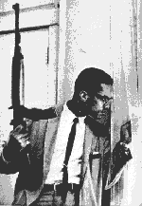
Assassination of Malcolm X
- Tensions arose between Malcolm and the __________________________________
- He was shot 16 times during a speech in 1965

COMPARE & CONTRAST
Using your notes, compare and contrast Martin Luther King, Jr. and Malcolm X by completing the Venn Diagram below. After completing the diagram, move onto the primary source videos worksheet.

