Name: _________________________________________________ April 10, 2014 Period: ________

Franklin Roosevelt & the New Deal

Directions: Using the reading for today, fill in the notes, answer the questions, and complete the chart questions. By doing so you will not only be expanding your mind and your horizons, but you will also be fully prepared for tomorrow’s test. I shouldn’t have to say this, but the New Deal is kind of a BIG deal. Got it?
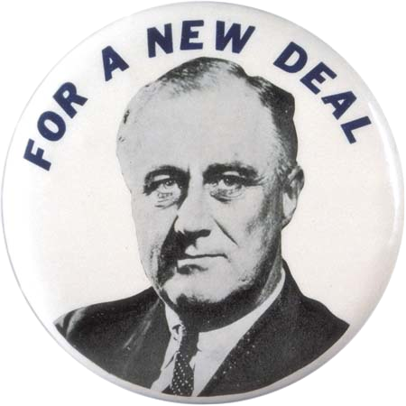
ROOSEVELT TAKES OVER

Franklin Roosevelt was different from Herbert Hoover in two ways.
- First, he gave Americans ________________, beginning with his inaugural address.
- Second, he was willing to try new ideas and change the way _____________________ worked.
1. Who was a part of Roosevelt’s Brain Trust?

THE HUNDRED DAYS

In the New Deal’s first Hundred Days, FDR sent Congress a pile of bills to pass, which they did. The three goals of these bills were:
RRR
- _____________________ for the hungry and jobless
- _____________________ for agriculture and industry
- _____________________ to change the way the economy worked

RESPONSES TO THE NEW DEAL

4. Not everyone liked the New Deal. Some said it went way too far. Others said it didn’t go far enough. What did voters think about the New Deal in the 1934 elections?

THE SECOND NEW DEAL

5. In 1935, Congress passed one of the most important bills of the century. It was called the __________________________________. What did this Act do?

6. Why did African-Americans switch from the Republican Party to the Democratic Party in the election of 1936?

ROOSEVELT FIGHTS THE SUPREME COURT

7. The Supreme Court did not like all of Roosevelt’s programs in the New Deal. In order to get more support, Roosevelt tried to add more judges to the Supreme Court. What was the outcome of Roosevelt’s attempt to “Pack the Court?”

THE NEW DEAL SLOWS DOWN

8. What is deficit spending? Why did Roosevelt use it?
Questions 9-12: Use the chart to answer the questions that follow.

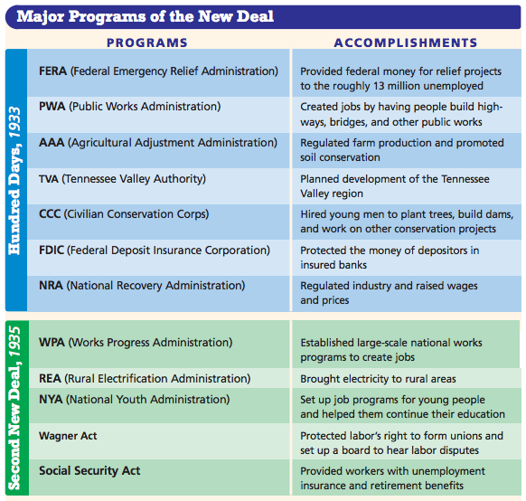

9. How did programs like the PWA, CCC, and REA help all Americans in addition to the people these programs employed?

10. How did the FDIC give Americans more confidence in putting their money in banks?

11. How did the Second New Deal help both young people and old people?

12. Which of these programs do you think was the MOST important? Why?

INFORMATION TO STUDY FOR THE TEST:

- 1920s Booming Economy
- 1920s Culture
- Buying on Credit
- Causes of the Great Depression
- Life during the Great Depression
- Responses to the Great Depression
- FDR and the New Deal

