Name: _________________________________ Date: _______________________ Period: _______

Non-Violence in the Civil Rights Movement

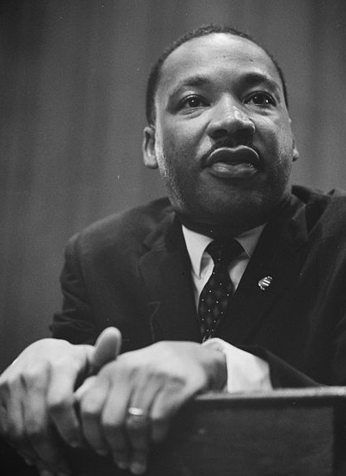
Nonviolence
- Definition
  - ________________________________________________________________________________________________________________________________________________________________________
- Some nonviolent organizations:
  - Montgomery Improvement Association (_____________)
  - Southern Christian Leadership Conference (_____________)
  - Congress of Racial Equality (_____________)
  - Student Nonviolent Coordinating Committee (_____________)

Martin Luther King, Jr.
- Leader of the nonviolent Civil Rights Movement
- Led the ______________________________________________ and later founded the SCLC
- He was inspired by _____________________________________ and believed in nonviolence
- It was the nonviolent movement which would bring about Civil Rights legislation

Montgomery Bus Boycott
- Led by ________________________________, MLK, among others
- Blacks refused to ride the buses in order to try to end segregation on them
- Montgomery, AL
- Dec. 5, 1955-Dec. 21, 1956
- The boycott was ____________________________, and the buses integrated
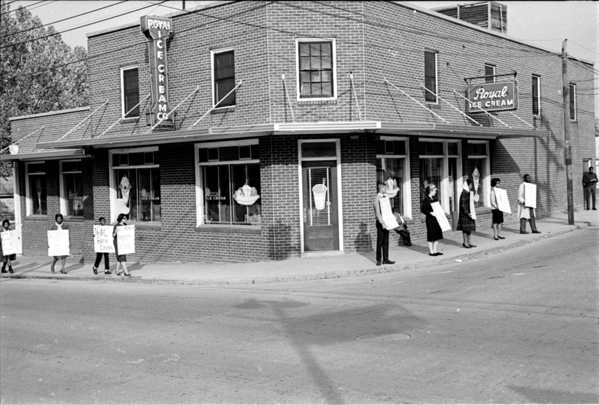
Sit-in
- ___________________________________________________________________________________________________________________________________________________

Royal Ice Cream Sit-ins
- 1957
- Protesters organized a sit-in to try and integrate the __________________________________________ in downtown Durham, NC
- They were arrested and fined ___________ each
- They appealed their case all the way to the U.S. Supreme Court, but ____________ the case
Greensboro Sit-ins
- On __________________________, four black college students sat down at a whites-only lunch counter at Woolworth’s
- They refused to leave for the entire day and endured a lot of harassment
- They came back every day with even more demonstrators which grew to over _____________
- Despite a bomb threat, Woolworth’s finally integrated
- ________________________ like those in Greensboro began to happen throughout the country
- In Durham, NC, sit-ins were used to integrate the ______________________________________

March on Washington
- On August 28, 1963, over _____________________ people went to Washington, D.C. to march for “jobs, justice, and peace”
- It was the largest Civil Rights demonstration in Washington, D.C.
- Led by MLK, it is where he gave his famous “__________________________________” speech
- The march helped finally bring about Civil Rights Legislation

Freedom Summer of 1964
- In 1964, over 1000 college students, most of whom were white, traveled to Mississippi to conduct schools for black children and to help blacks ________________________________
- This was called the _________________________________________
- The students faced a lot of hostility
  - ______ were beaten
  - over __________ were arrested
  - ______ died (3 in Neshoba County)
- The men killed in Neshoba County had been investigating a church ___________________________
- They were arrested and released to a mob who murdered them
- Their murderers were only convicted of Civil Rights violations
