Name ____________________________________ March 11, 2014 Period: ______
Populism
Farmers: Where it all began.
- In the late 1800’s farmers were trapped in a vicious _______________ cycle.
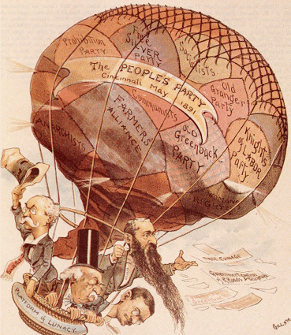
    - Prices for crops falling.
    - Mortgaged their farms to buy more land and produce more crops. They could not ________________________________.
    - Railroad companies also ______________________ them for shipping.
It’s the Economy!
- During the Civil War, the U.S. Government issued $500 million in _______________________ (paper money).
- Greenbacks were worth less because they could not be exchanged to gold and silver.
- So, they retired the greenbacks.
What is wrong with this picture?
- If you retire greenbacks, the ____________________________ is worth more.
- HOWEVER….
    - Our farmer friends who mortgaged their farms now had to pay back the loans in dollars that were worth more than the dollars they had borrowed.
    - At the same time, they were receiving__________________for their crops.
    - Meanwhile, farmers paid outrageously high prices to transport grain via railroads.
The Grange
- 1867: Oliver Kelley starts the ________________________, an organization for farmers that became known as the ____________________.
- _______________________________- the Grange gave rise to these alliances that sympathized with farmers and sent lectures from town to town to educate people. Membership soon grew to 4 million!
Power to the People!
- Alliance movement needed a ______________base. In July of 1892 in Omaha, NE, the ______________________ People’s Party was born.
- They demanded a greater voice of the people in government and reforms to lift the farmers’ burden of debt.
Populist Party Platform:
- _______________________________________________________________
- _______________________________________________________________
- _______________________________________________________________
- _______________________________________________________________
- _______________________________________________________________
- _______________________________________________________________
Panic of 1893
- Farmers were overburdened with ________________ and failed to pay back their loans.
- By the end of the year, over 15,000 businesses and 500 banks had collapsed!
- By 1894, over one-fifth of the workforce was unemployed.
Bimetallism and Gold Standard | Gold Bugs | Silverites
Who they were.
What they Wanted.
Why
Effects

The Candidates
- Election of 1896: Republicans elect an Ohioan,_________________________.
- Democratic Party elected ______________________________, whom the Populists also supported.
All Good Things Must End
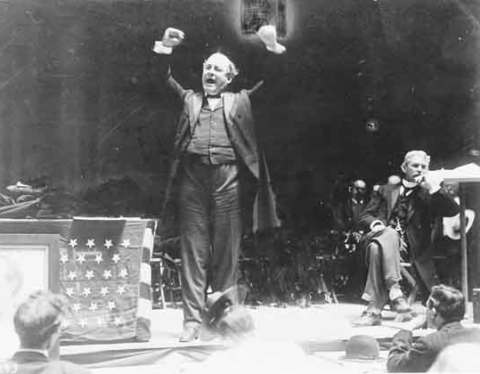
- McKinley’s victory over William Jennings Bryan brought __________________ to an end.
- Why?
  - The __________________ experienced rapid change.
  - The era of small producers and
farmers was fading away.
  - _____________ divided the Populist Party,
especially in the South.
  - The ___________________ were not able to break
existing party loyalties
- The movement left two powerful legacies:
    - The oppressed could organize and have a _________________________.
    - Plenty of ____________________, many of which would be enacted in the 20th century by Progressives.

SOURCE: http://www.meridianschools.org/MVHTeachers/M-P/Martinez/USHist11/Lists/Calendar/DispForm.aspx?ID=10

