Name: ________________________________________________ Date: ____________________________ Period: _______

Review Packet #3 – Unit 2: The Colonial Era

UNIT RECAP
A colony is an area under the control of another country, typically a distant one, and occupied by settlers from that country. It can also refer to a group of people who settle in a distant land but who are still under the rule of their native land. The British, French, Spanish, and Dutch established colonies in North America. While they had some different goals, they all colonized for one of three reasons: (1) to make money by finding gold and silver or farming crops that they could not grow back in Europe; (2) to find a Northwest Passage to make the trip to Asia faster; and (3) to convert Native Americans to Christianity.

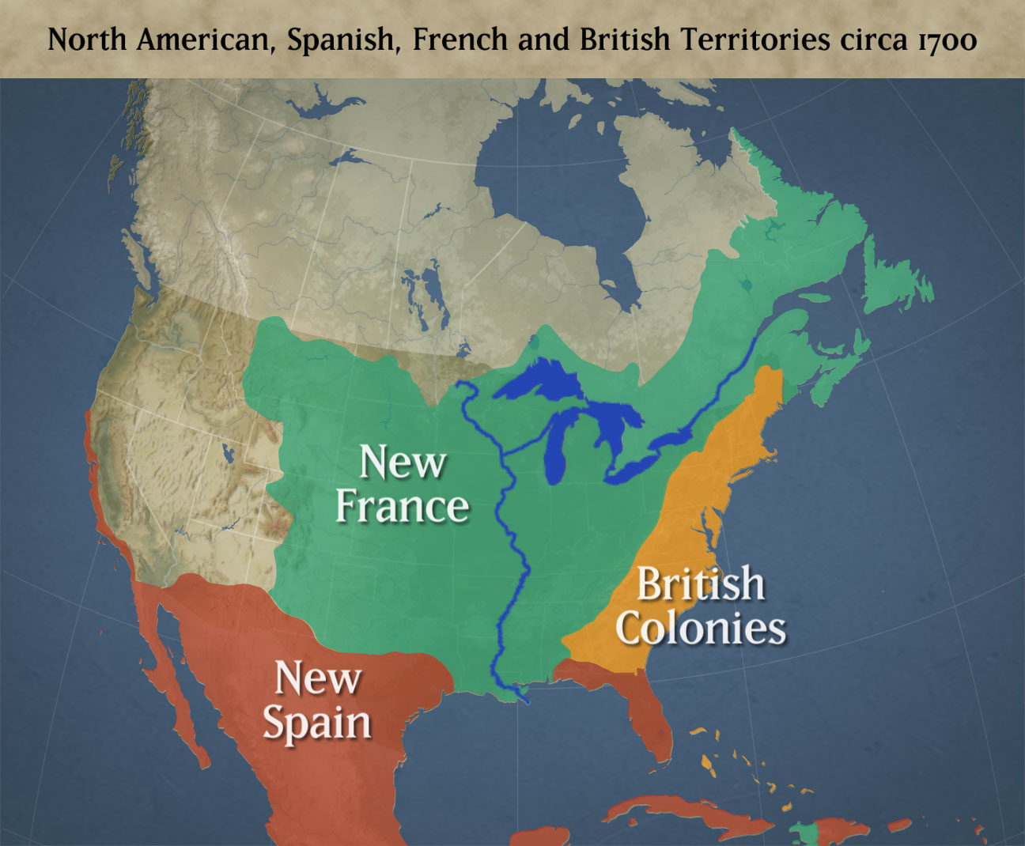

French colonies were mostly found in Canada and the Midwest. In addition to the reasons listed above, the French also traded for furs with Native Americans. The French tended to have a better relationship with Native Americans than the British because of this trading. Spanish colonies were located in Florida, Mexico, and California. The Spanish mainly relied on gold mines and farming to make money off of their colonies.
The first British colony established in North America was at Roanoke in North Carolina (then part of Virginia) in the year 1585. Roanoke faced many hardships, including being far away from home, dealing with difficult weather conditions, a lack of supplies, and conflicts with Native Americans. For these reasons, the colony at Roanoke was abandoned. We do not know exactly what happened, however, as there was no evidence of why the colonists left or died. The word CROATOAN carved on a tree provided the only hint to this unsolved mystery.
Even after Roanoke, the British tried again to colonize North America. Their second attempt at Jamestown, Virginia in 1607 was successful. The success of Jamestown was largely due to lessons learned at Roanoke. More supply ships, a better leader (John Smith), and an emphasis on farming helped the colony survive and thrive. Also, Pocahontas helped establish positive relations between the colonists and the Powhatan Indians. Trade between the Powhatans and the British was very important to the colony.
The colony of Carolina was created in 1663 as Virginians moved south looking for cheap, available land to grow tobacco. After several instances of unrest, Carolina was split into two colonies in 1712. One reason was because of rebellions, like the Culpeper Rebellion (1677) and the Cary Rebellion (1703). By splitting the large colony into two, North Carolina was easier to govern.
Overall, the 13 original British colonies developed very differently from each other. That will be the target of our next review packet.

UNIT RECAP QUESTIONS

- What were the main reasons Europeans colonized America?

- What countries set up colonies in North America?

- Why did the French have a better relationship with Native Americans than the British?

- Why did the colony at Roanoke fail?

- Conversely, why did the colony at Jamestown succeed?

- Why was the colony of Carolina created?

- Why was it split into two colonies?

PRACTICE TEST QUESTIONS

8. What is the term for “an area under the control of another country, typically a distant one, and occupied by settlers from that country?”
a. Columbian Exchange
b. Colony
c. Roanoke
d. Mission

9. Which of the following was NOT a goal of the British when colonizing Roanoke?
a. Converting Natives to Christianity
b. Making money through farming or finding gold
c. Finding a Northwest Passage
d. Trading for furs with Natives

10. Why did the FIRST colony at Roanoke fail?
a. Colonists were not prepared for fighting with Native Americans
b. The supply ships did not deliver supplies quickly enough to colonists there
c. The harsh winter caused colonists to leave the colony and go back to England
d. The forced labor program of Captain John Smith made colonists want to leave

