Name: ________________________________________________ Date: ____________________________ Period: _______

Review Packet #9 – Unit 6.1: Industrial Revolution

UNIT RECAP

The Industrial Revolution was a time period during the 1700s and 1800s, beginning in Great Britain and spreading to other countries. This time period experienced a change from making things by hand to making them in factories with machines. In the United States, the Industrial Revolution occurred mostly in Northern cities from the mid-1800s until World War I. The Industrial Revolution was caused by a number of things:
- The Agrarian Revolution – new farming technology allowed the production of more food, increasing the population in many countries
- Natural Resources – countries that experienced the Industrial Revolution, like the United States, had an abundance of natural resources
- Capital – countries that were able to industrialize did so because they had the capital, or money, to do so
- People – In order to expand industry, workers were needed
- Technology – as the Industrial Revolution began, new inventions and technologies helped it expand

The Industrial Revolution had countless effects, but some of its most major effects were seen in the United States. First, mass production allowed industrialized nations to produce goods in huge amounts. Inventions such as the steam engine, cotton gin, and spinning jenny increased production rates and allowed more to be produced. This also allowed the goods to be sold more cheaply.
In the early 1900s, the assembly line (popularized by Henry Ford) would increase this mass production. Inventions such as the telegraph and telephone improved communication. Steel became the primary building material in industrialized nations. Light bulbs lit up cities for the first time. It was truly a revolution (a dramatic, quick change)!
Other effects included: the creation of big businesses, new and better technology, the development of a middle class and working class, urbanization, harsh working conditions, imperialism, and war. These effects were both positive and negative for the United States.
Urbanization refers the to shift in population from rural, farming areas to cities. Rapid urbanization in the United States led to many positives and negatives. Due to the need for workers, many immigrants came to the United States looking for work. Even though they were promised a good lifestyle, many immigrants struggled and lived in very poor conditions in cities. This difference between what America looked like from the outside and the reality on the inside became known as the Gilded Age.
During the Gilded Age, the growth of industry and the amount of money being raked in by companies made America look like a land of wealth and riches. In reality, there was political corruption, immigration problems, racism, low pay, long hours, and rough conditions. While people could still improve their situations, it was very difficult to do so.
Even in North Carolina, the Gilded Age characteristics were evident. As tobacco companies grew and added more technology to the process, families such as the Dukes, became very wealthy. The railroad-owning Vanderbilt Family built the largest private home in the United States at the Biltmore Estate in the western part of North Carolina. Oh, did I mention it was only a vacation home? Meanwhile, many people in the state struggled on farms. Sharecropping kept many farmers, especially African-American farmers, poor and in debt to landowners. Segregation, racism, and Jim Crow Laws also added to the poor conditions of the South during the Gilded Age.

UNIT RECAP QUESTIONS

- What was the Industrial Revolution? When did it occur? Where did it start?

- What were some of the causes of the Industrial Revolution?

- How were natural resources important to the Industrial Revolution?

- List three positive effects of the Industrial Revolution.

- List three negative effects of the Industrial Revolution.

- What is urbanization?

- What was the Gilded Age? Why was it called this?

- What did the Gilded Age look like in North Carolina?

- What was sharecropping?

- What was life like for African-Americans in North Carolina during the Gilded Age?

PRACTICE TEST QUESTIONS

11. 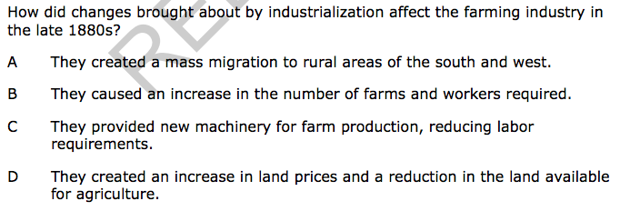

12. 