Name: _____________________________________________ May 1, 2014 Period: ______

Roots of the Cold War

COLD WAR
- Definition: ___________________________________________________________________________
____________________________________________________________________________________
____________________________________________________________________________________
- Two _________________________
  - United States vs. Union of Soviet Socialist Republics
- Mainly a conflict between _________________________ & _________________________ nations
- Why is it called the “Cold” War?
  - No direct conflict on the _________________________
  - The U.S. and Soviet Union did engage in _________________________ (spying), propaganda, athletic, and political “battles” around the world.
Learning Target #1 Recap
  - Cold War begins as _________________________ ends
  - Between capitalist nations (led by _________) and communist nations (led by ______________)
  - No direct fighting between U.S. and Soviets
  - Ends in 1990s

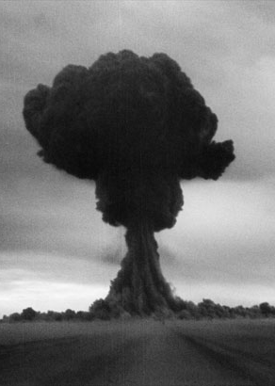
CAUSES
- Competition between superpowers
- Nuclear weapons
- Disagreements/distrust over end of WW2
- U.S. policies toward communism
- Alliances
Competition
- The U.S. and Soviet Union competed in nearly everything – List 6 things that the U.S. and Soviets competed over:

Nuclear Weapons
- The U.S. and Soviet Union began building up their nuclear arsenal, just in case the countries went to war.
- Nuclear annihilation was the ____________________ _____________________ of the Cold War
Disagreements & Distrust
- Democratic nations (United States, France, & Britain) wanted free elections in Eastern European elections after WWII
- Soviet Union would not allow; instead, they set up ____________________________ governments in places like Poland and East Germany
- These nations were called _______________________________ of the USSR
U.S. Policies
- ____________________________________
  - U.S. tries to keep communism from spreading to more countries
- Marshall Plan
  - U.S. gives ____________________ to countries to keep them from turning to communism
Alliances
- North Atlantic Treaty Organization (_________________)
  - U.S.-led alliance between democratic nations
- Warsaw Pact
  - _____________________-led alliance between communist nations and Soviet satellite nations
- These were military, as well as political, alliances
Learning Target #2 Recap
- The Cold War was caused by competition between the two superpowers—__________ & ___________
- Each side tried to get more power and influence around the world
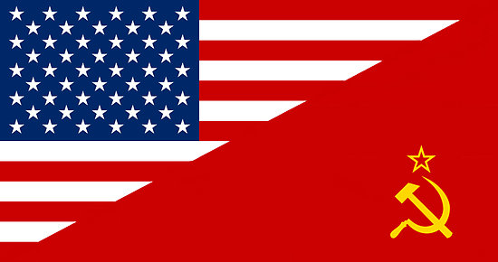
- _____________________ war was a real possibility

