Name: ________________________________________ 2/27/14 Period: ______
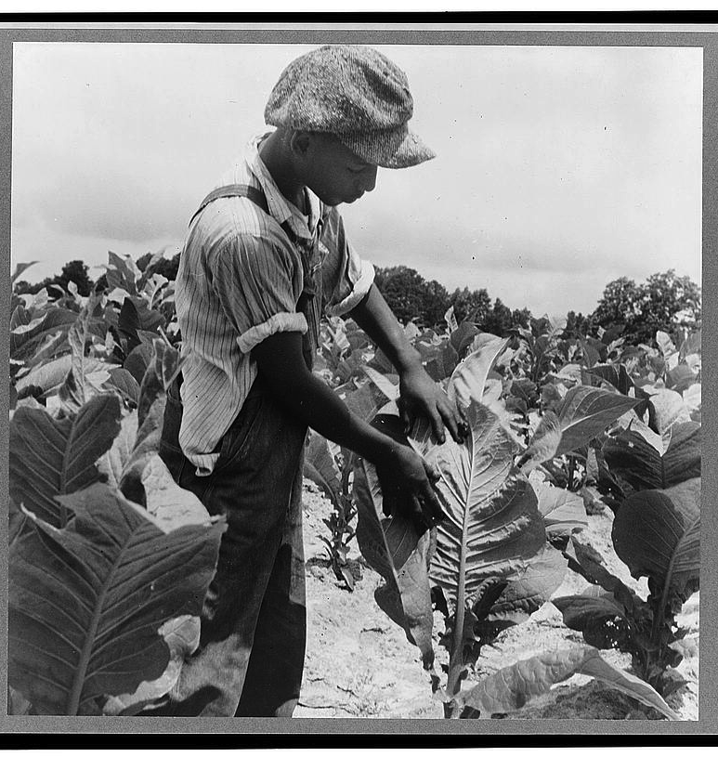
Sharecropping & Segregation in North Carolina
Agriculture in NC
- Farming continued in NC during the Industrial Revolution
- Because the prices of cotton and tobacco ___________________________________ after the Civil War, many farmers went into ____________________________
- Many farmers turned to political organizations for help (We’ll talk about that in our next unit!)
Sharecropping
- From 1880 and 1900, thousands of white and black farmers became ____________________________
- Sharecroppers did not own the land, the house, or the machinery
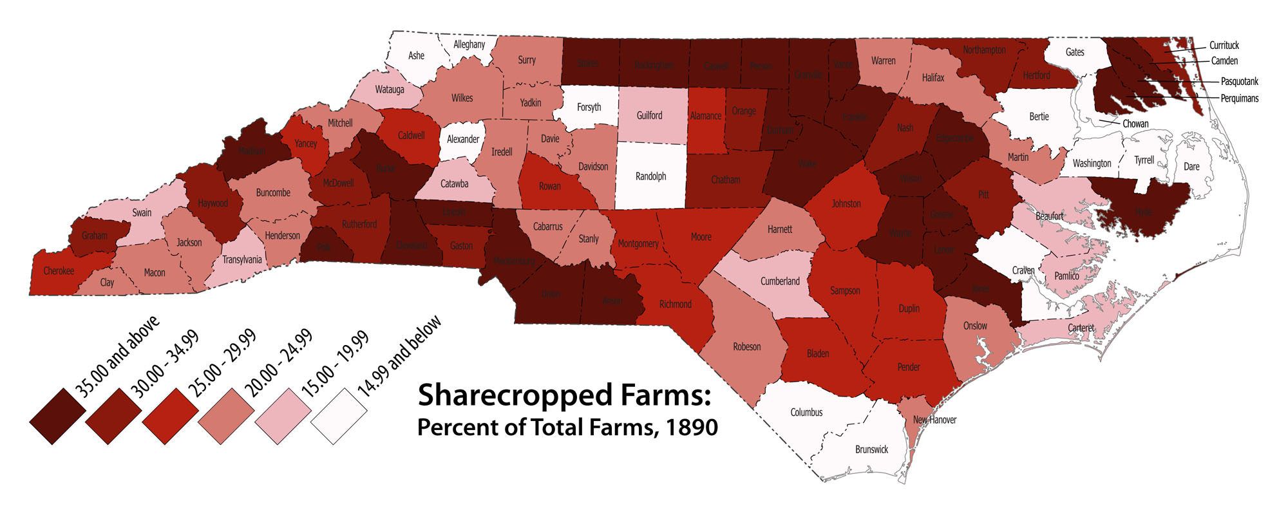
- They had to pay ______________________in the form of a portion of the yearly crop
- Life was miserable for many croppers
- Many could not make a profit due to the low prices
- Landowners often charged high prices in order to keep them in debt
- Many left farms for ____________________________ jobs in cities

Jim Crow
- Jim Crow Laws
  - Laws that enforced ____________________________ in the South
- Named for an old ____________________________ show that made blacks look foolish and dependent
Voting Restrictions
- ____________________________Tests
  - If you couldn’t read, you couldn’t vote
  - Hurt black voters who did not receive an education
- ____________________________Clause
  - If your grandfather could vote before 1867, you could vote anyways
  - Excluded blacks whose grandparents had been slaves
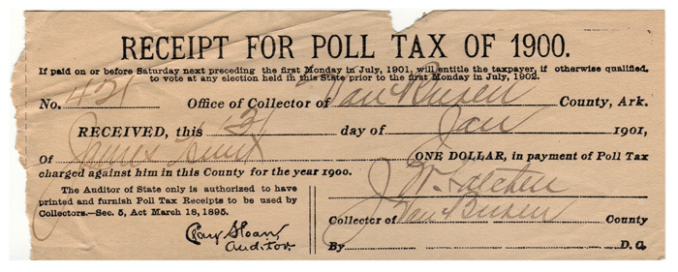
- Poll ____________________________
  - Fees for voting
  - This especially hurt poor farmers and factory workers

Segregation
- Definition
  - ____________________________________________________________________________________
- Segregation was enforced by ____________________________ and ____________________________
- Going against customs could have deadly results for African-Americans
Plessy v. Ferguson
- 1896
- Supreme Court case about segregation on train cars
- The decision set the ____________________________ (standard for later decisions) that segregation was legal
- “Separate, but ____________________________”
Life in Segregation
- Many whites refused to give blacks any respect (e.g., refusing to use titles)
- Black and white society mostly operated separately
- Violations of ____________________________ could result in deadly consequences
  - ____________________________ (mob murder by hanging, shooting, or burning) was not uncommon

