Name: __________________________________________________ Date: __________________________________ Period: ________

Urbanization
Directions: For this activity, you must complete ALL of the 5 sections below. Each section has its own directions, so READ CAREFULLY!

DEFINE: Define urbanization. (1 pt.) | DRAW: Draw a picture representing an urban place. (1 pt.)
LIST: What are two positive consequences of urbanization during the Industrial Revolution? (2 pts.)  1. __________________________________________________  2. __________________________________________________ |  | CHARTS & GRAPHS: Use the chart below to answer the questions that follow. (3 pts.)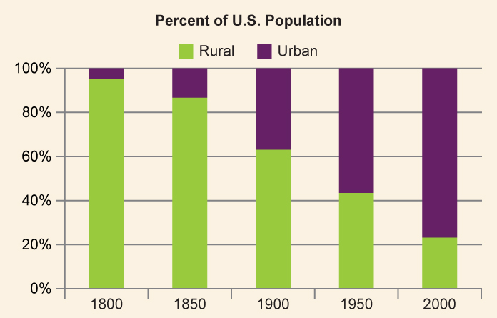  According to the chart above, what percentage of Americans lived in urban areas in 1800? By 1900?  According to the chart above, where do most Americans live today (use the year 2000), in urban or rural areas?  Why did many Americans move to urban areas during the 1800s and early 1900s?
WRITE: What were some of the negative consequences of urbanization during the Industrial Revolution? (3 pts.)

____________________________________________________

____________________________________________________

____________________________________________________

____________________________________________________

____________________________________________________

____________________________________________________

____________________________________________________

____________________________________________________

____________________________________________________

____________________________________________________

____________________________________________________

____________________________________________________

