Name: _____________________________________ March 24, 2014 Period: _______
The Entry of the U.S. into WWI
President Woodrow Wilson
- Became president in _______________ in a close election
- Democrat who supported the _____________________________ Movement
- Controversial views on race (he supported segregation)
- People liked how he wanted to stay out of WWI

Neutrality
- In the beginning of the war, the United States wanted to remain __________________________.
- This continued a policy of the U.S. to remain isolationist
- Wilson was re-elected in 1916 with the slogan: “___________________________________________!”

READ DOCUMENT A (from 1914)
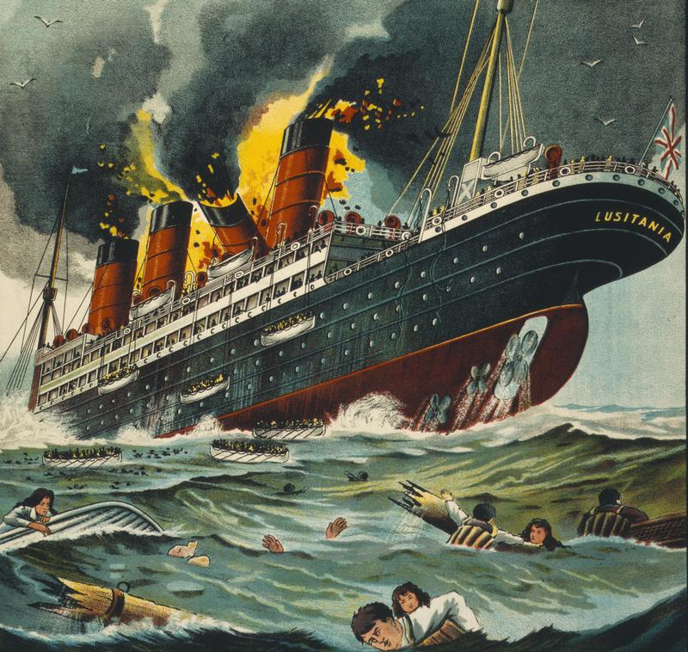
What pulled America into the War?
- Unrestricted ______________________________ (U-boat) warfare
  - The sinking of the Lusitania
  - Sussex Pledge is broken
- The Zimmerman ______________________________

Unrestricted Submarine Warfare
- According to ___________________________________________, civilian ships must be warned before sinking – allowing for passengers to escape to safety.
- Germany was not doing this!

- The Sinking of the ______________________________
  - British passenger liner that set sail from New York carrying American citizens.
  - It was sunk without warning on May 7, 1915 off the coast of Ireland
  - 1,198 lost; _________________ US citizens died
  - Germans claimed the Lusitania was carrying war materials: guns, ammunition, etc. (She was!)

- The Sussex Pledge
  - After Germany sunk another ship, The Sussex, President Wilson protested
  - Germany issued the _________________________________________
    - They would not “sink merchant or passenger ships without warning and without saving human lives.”
  - The Sussex Pledge _________________________
    - On February 1, 1917 Germany continued unlimited submarine warfare
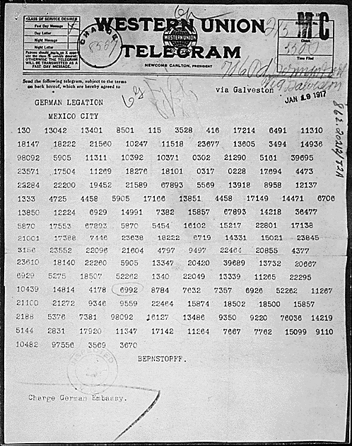
The Zimmerman Telegram
- Germany sent a coded message to ____________________________ to try to get them to enter a secret alliance
- Germany would support Mexico and help it get land back from the U.S. in exchange for Mexican support
- AMERICANS WERE ______________________________!!!

America Declares War
- April 2, 1917
  - President Wilson asked Congress for a _______________________________ against Germany
- April 6, 1917
  - Congress declares war!!

READ DOCUMENT B (from 1917)

