Name: _______________________________________________ March 21, 2014 Period: ________

Becoming a World Power

Imperialism
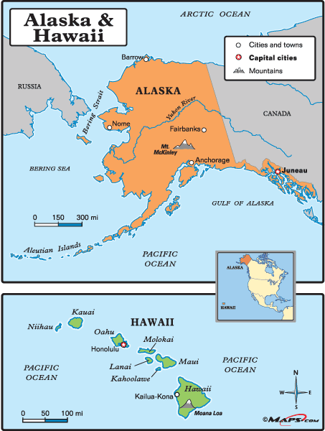
- The policy by which __________________________ nations extend their economic, political, or military control over __________________________ territories
U.S. Expansion
- Many Americans in the late 1800s supported U.S. expansion due to three reasons:
- __________________________ Interests
    - New territories mean more people to buy American products
- __________________________ Interests
    - Establishing military bases overseas could keep Americans safe at home
- __________________________ Superiority
    - Many Americans believed their government, religion, and race were superior to other societies
Alaska & Hawaii
- The United States bought Alaska in 1867 for $7.2 Million
  - Originally seen as a mistake until __________________________ was discovered there
- The United States annexed Hawaii in __________________________
  - Benefits:
    - __________________________ station for U.S. Navy
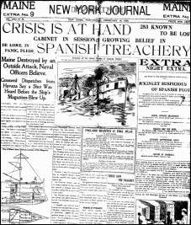
    - American-owned sugar plantations made a lot of money
Expansion through War
- In the 1890s, the United States became worried about a revolt in Spanish-owned __________________________
- The United States traded a lot with Cuba, and relied on Cuba to buy American products
- ___________________________________________________ wrote sensational stories about Spanish cruelty toward Cubans which made many Americans want to go to war with Cuba
Spanish-American War (1898)
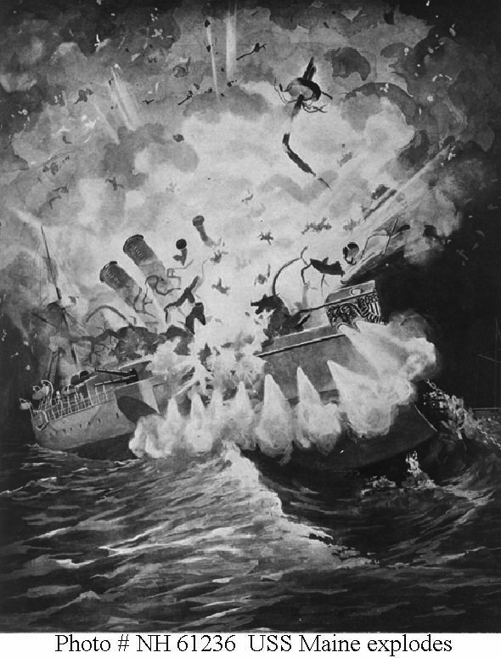
- Causes
  - Americans were eager to go to war to stop __________________________ “cruelty”
  - Yellow journalists were writing stories to encourage war to get more readers
  - The _____________________________, an American battleship, exploded in Cuba, killing 260 sailors
    - This may have been an accident, but journalists and Americans blamed it on Spain
    - “Remember the Maine”
- Results
  - The United States won the war within the year and gained the following territory around the world:
    - __________________________
    - __________________________
    - __________________________
  - Cuba became a free country, but the United States had a major influence with everything they did
U.S. Influence in China & Latin America
- China
  - The United States fought to keep trade with ________________________ open to all countries, not just a few
- Latin America
  - The U.S. built the _________________________________________ to increase trade
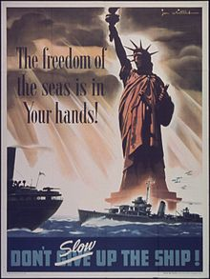
  - Also, the U.S. “policed” the region to make sure that the interests of the United States were protected
How does this relate to WWI?
- The United States now had __________________________ all over the world to sell its goods.
- Goods were transported by ship to these places
- The United States would enter World War I to protect its rights to ship goods wherever it wanted
  - This is called “____________________________________________”

