Name: ____________________________________________ Date: ______________________________ Period: _________

The Vietnam War
Background
- Vietnam is located in Southeast Asia
- Formerly colonized by France as part of ________________________________________________
- French were kicked out after _____________________________________ led a Communist revolution
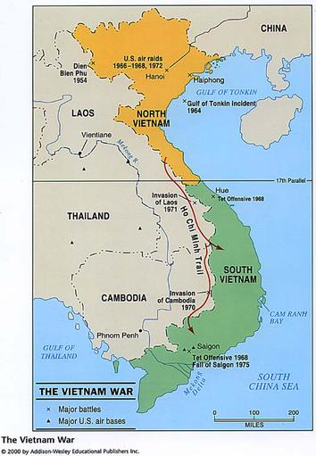
North Vietnam vs. South Vietnam
- _________________________________ led Communist North Vietnam
  - Backed by China and Soviet Union
  - Army called the _______________________________
- South Vietnam had a ______________________________
  - Backed by France and the U.S.

Cold War & Domino Theory
- Domino Theory in Action:
  - Believed that if Vietnam fell to ____________________________, all of Southeast Asia would become communist
- How is this related to the policy of containment?
__________________________________________________________
__________________________________________________________
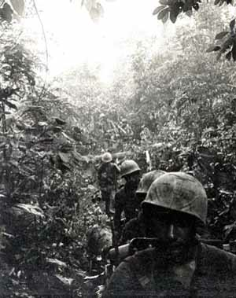
U.S. Gets Involved
- U.S. sent “advisors” to South Vietnam to work with government and train their military
- Gulf of Tonkin Incident (1964)
  - North Vietnamese allegedly attack a U.S. Navy ship
  - Congress approves military action with the ______________________________________________________

The Quagmire
- The U.S. got bogged down in Vietnam
- U.S. held major cities, but the Viet Cong’s ____________________________________ tactics caused the U.S. to have trouble fighting in the jungles
- U.S. sends __________________________________ troops by the end of 1966

U.S. Opinions Turn
- Americans begin to turn against the war for many reasons:
  - Viet Cong making gains in the South
  - Opposition to the ________________________________________________
  - Photos and video of dead American soldiers on television
  - Spending nearly ___________________________________ a month
  - Peaceful and violent protests broke out all over the country

End of the War
- __________________________________________
  - U.S. begins to withdraw troops and turn war over to South Vietnamese in the 1970s
- Paris Peace Accords (1973)
  - U.S. agreed to leave Vietnam
  - North and South had tentative peace
- ___________________________ Falls
  - Fighting renews in 1975, capital of South Vietnam falls to the Viet Cong

Consequences of the Vietnam War
- Vietnam united as a __________________________________ nation
- U.S. Congress passes laws to limit the use of the military
- 26th Amendment
  - Voting age changed from 21 to __________ for everyone
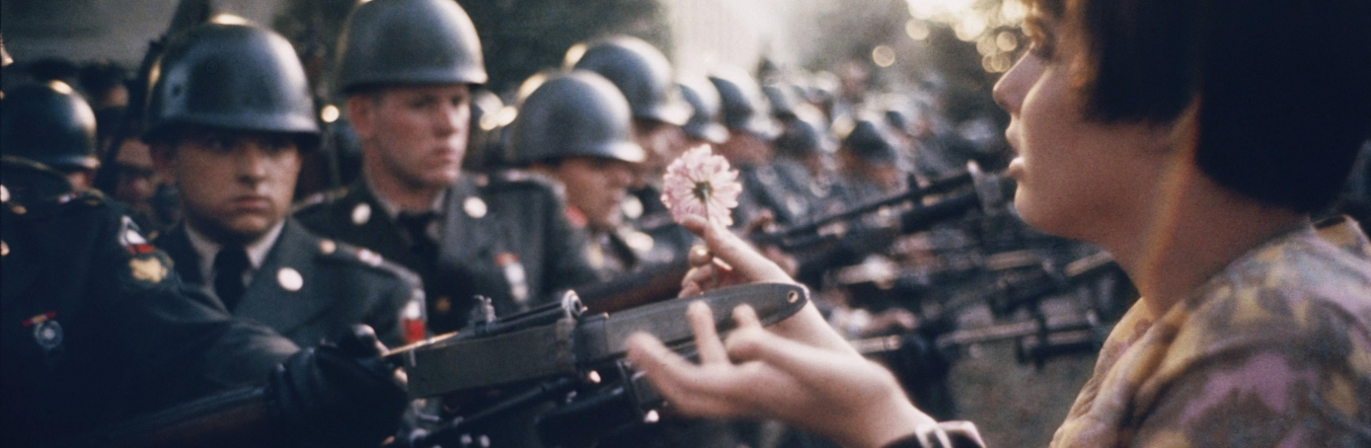
- ___________________________________________________ war in U.S. history (Afghanistan is now the longest)

