Name: ________________________________________ Date: ______________________ Period: _______

African-American Leadership in the Early 1900s

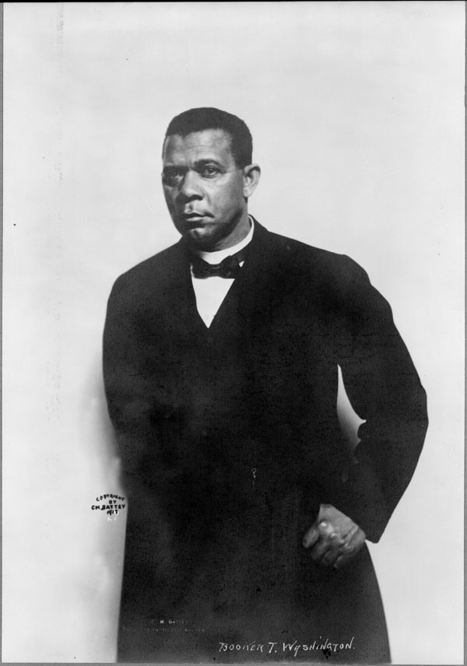

BOOKER T. WASHINGTON

Basics
- Lived ____________ - ____________
- Born a slave in Virginia
- Educated at Hampton University
- Founder of ____________________________________________

Views
- Outlined his beliefs in his “_______________________________________” speech in 1895
- Believed that blacks should not blame whites for their situation
- Blacks should start from the bottom, work their way up and “be patient”
- Work for economic opportunity
- Opposed agitating for black rights because it would cause setbacks in achieving those rights

How did he try to achieve his vision?
- Wanted programs for _____________________________ and _____________________________ for black Americans
- Ask whites to give job opportunities to Black people
- B.T.W. went on to found the ___________________________________ which provided jobs and training for blacks
- B.T.W. was unpopular with many Black leaders, but was popular with white leaders in the North and South. Why?

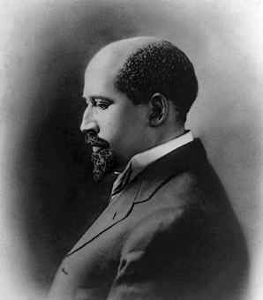

W.E.B. DuBois

Basics
- Born in Massachusetts to a free black family
- Lived ____________ - ____________
- Educated at Fisk, Harvard, & Berlin
- Sociology Professor at Atlanta University in 1897

Views
- Views given in ___________________________________________
- Strongly opposed B.T.W.’s acceptance of segregation and Jim Crow
- Felt that white people caused problems by denying rights to Black people

How did he try to achieve his vision?
- Advocated the “________________________________________”
- Felt that talented African-American students should get a good education and then help everyone else rise to higher standards
- Felt it was wrong to expect a citizen to “earn their rights”
- Founding member of the ____________________

NAACP
- National Association for the Advancement of Colored People
- Founded by 60 people, _________ of whom were African-American (including ______________________ & ______________________________________)
- NAACP's stated goal was to secure for all people the rights guaranteed in the 13th, 14th, and 15th Amendments to the Constitution
- DuBois was the only African-American among the organization's executives (even the NAACP’s president was a white man)

