Name: __________________________________________ Date: _____________________________ Period: ________

Washington vs. DuBois

COMPARE & CONTRAST
Using your notes, compare and contrast Booker T. Washington and W.E.B. DuBois by completing the Venn Diagram below. After completing the diagram, move on to the next section on the back of this page.

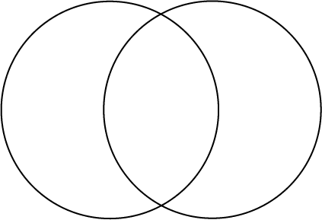
YOUR OPINION
After completing the Venn diagram, decide which side you are on in this debate.
First, choose which side you MOST agree with and list it below.
Second, begin brainstorming and writing down the reasons for your agree with your side and disagree with the opposition.
Third, think of ways you can prove the opposition’s points to be false.
Last, write a brief summary restating the key point of your argument.

Which person from today’s lesson do you agree with? (Circle one.)

Booker T. Washington (“Work for opportunities”) W.E.B. DuBois (“Talented Tenth”)

Why I think my viewpoint is CORRECT:

- ______________________________________________________________________________________________________

- ______________________________________________________________________________________________________

- ______________________________________________________________________________________________________

Why I think the other viewpoint is INCORRECT:

- ______________________________________________________________________________________________________

- ______________________________________________________________________________________________________

- ______________________________________________________________________________________________________

Summary:
_____________________________________________________________________________________________________________________________________________________________________________________________________________________________________________________________________________________________________________________________________________

